5. Project Development Phase

5.1 Admin Module

The Admin Module provides authorized administrators with tools to manage students, courses and enrollment records. It includes dashboard metrics, CRUD operations, course capacity management, prerequisite configuration and reports.

5.2 Student Module

The Student Module allows students to register or log in, maintain their profile, browse courses, search and filter available courses, enroll, withdraw and view enrollment status.

5.3 Course Module

The Course Module stores course ID, course name, description, credits, category, capacity and prerequisite information. Administrators can add, edit and deactivate courses.

5.4 Enrollment Module

The enrollment process validates the logged-in student, course availability, prerequisite conditions and duplicate enrollment before creating an enrollment record.

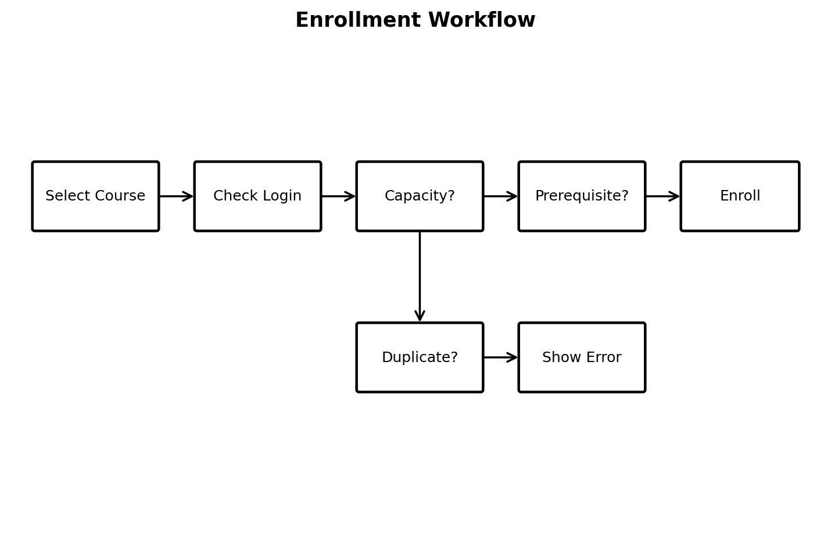5.5 AI Course Recommendation

The recommendation feature can first use transparent rules. For example, department match, interest match and eligibility can contribute to a relevance score. A later version can use a machine-learning model when sufficient historical data is available. The feature should explain why a course was suggested and must not automatically enroll the student.

5.6 AI Assistant

The AI Assistant answers questions such as course descriptions, prerequisites, enrollment steps and general system guidance. When connected to an LLM, the application should provide verified course/system data as context and avoid inventing unavailable courses, capacities or rules.

